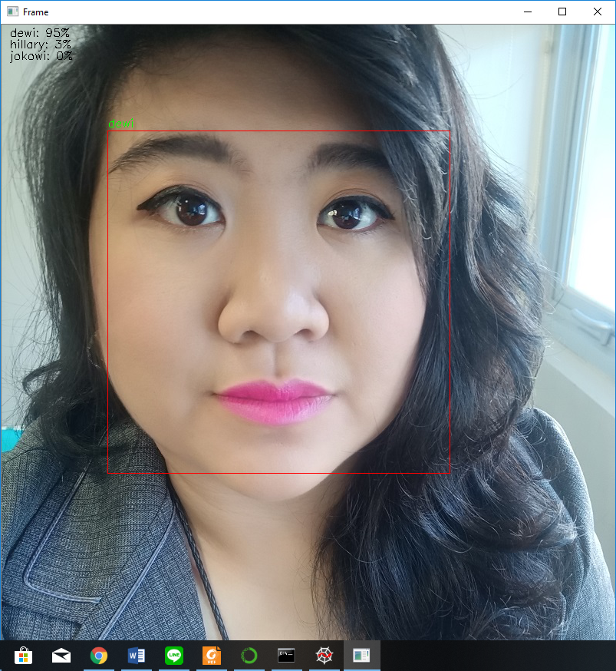

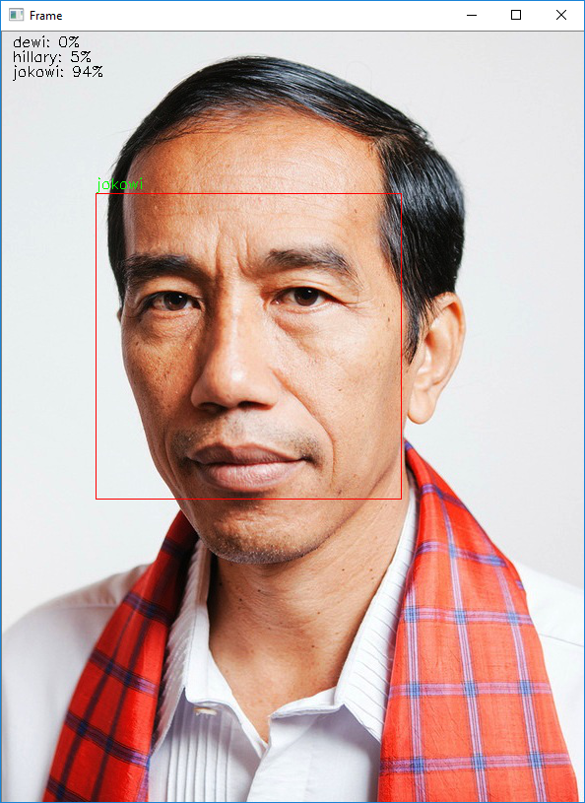

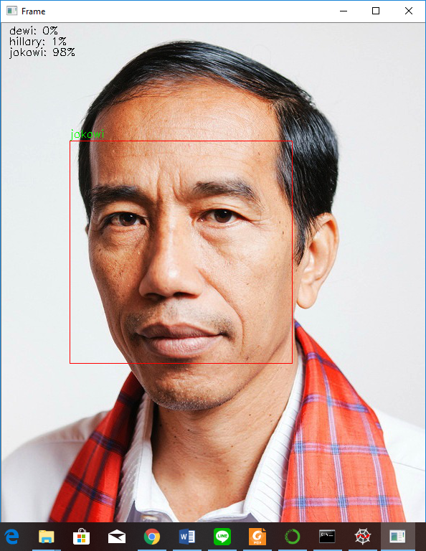

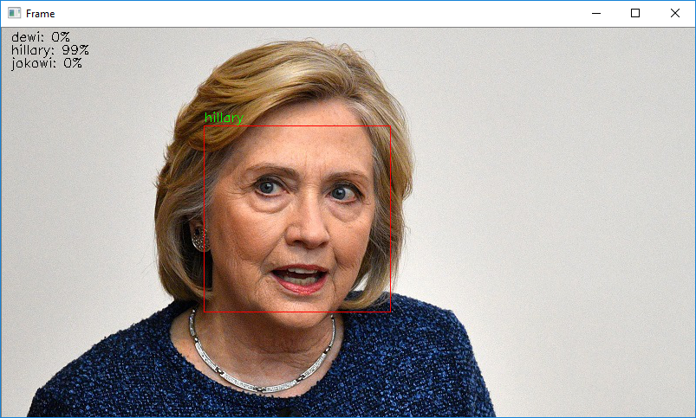



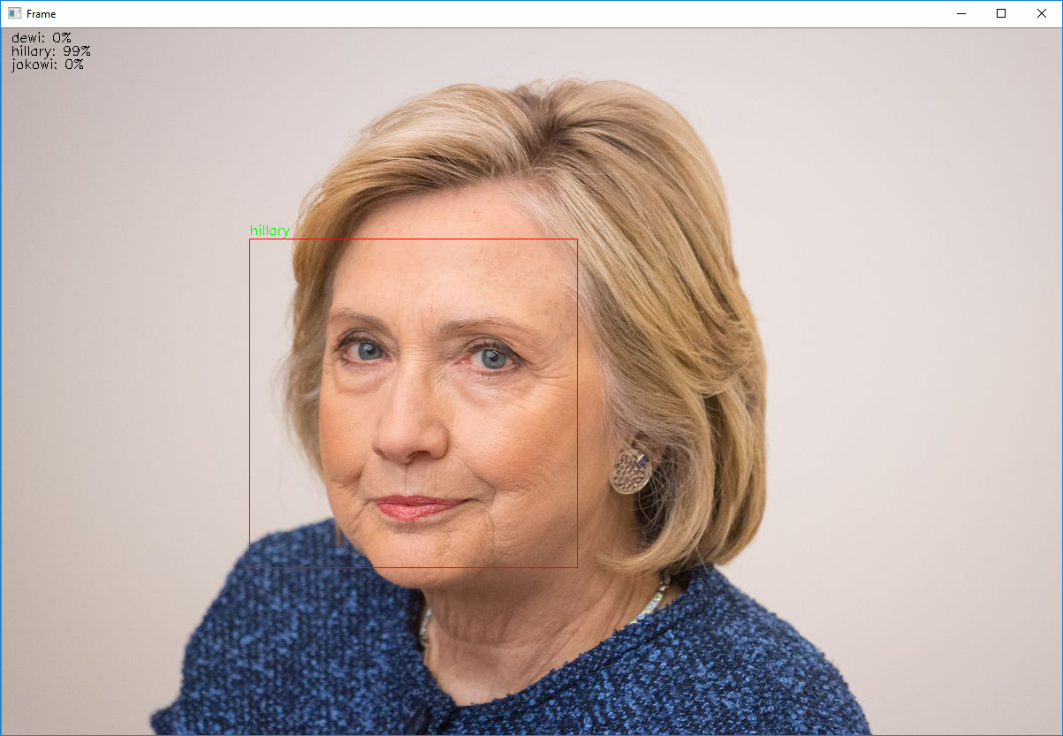



runfile('D:/PHD CYUT CHRISTINE 2018 - 2021/SEMESTER 2/7394 Artificial Inteligence and machine kearning/tensorflow/Face/traintest.py', wdir='D:/PHD CYUT CHRISTINE 2018 - 2021/SEMESTER 2/7394 Artificial Inteligence and machine kearning/tensorflow/Face')

['dewi', 'hillary', 'jokowi']

0

out_face/dewi

1

out_face/hillary

2

out_face/jokowi

(64, 64, 1)

_________________________________________________________________

Layer (type) Output Shape Param #

=================================================================

conv2d (Conv2D) (None, 64, 64, 32) 320

_________________________________________________________________

dropout (Dropout) (None, 64, 64, 32) 0

_________________________________________________________________

conv2d_1 (Conv2D) (None, 64, 64, 32) 9248

_________________________________________________________________

max_pooling2d (MaxPooling2D) (None, 32, 32, 32) 0

_________________________________________________________________

flatten (Flatten) (None, 32768) 0

_________________________________________________________________

dense (Dense) (None, 512) 16777728

_________________________________________________________________

dropout_1 (Dropout) (None, 512) 0

_________________________________________________________________

dense_1 (Dense) (None, 3) 1539

=================================================================

Total params: 16,788,835

Trainable params: 16,788,835

Non-trainable params: 0

_________________________________________________________________

None

Train on 23 samples, validate on 6 samples

Epoch 1/25

23/23 [==============================] - 1s 44ms/step - loss: 1.1249 - acc: 0.1739 - val_loss: 1.1104 - val_acc: 0.3333

Epoch 2/25

23/23 [==============================] - 0s 18ms/step - loss: 1.0883 - acc: 0.3913 - val_loss: 1.1181 - val_acc: 0.3333

Epoch 3/25

23/23 [==============================] - 0s 18ms/step - loss: 1.0279 - acc: 0.3913 - val_loss: 1.1247 - val_acc: 0.3333

Epoch 4/25

23/23 [==============================] - 0s 18ms/step - loss: 1.0144 - acc: 0.5652 - val_loss: 1.1177 - val_acc: 0.3333

Epoch 5/25

23/23 [==============================] - 0s 18ms/step - loss: 0.9857 - acc: 0.4783 - val_loss: 1.0941 - val_acc: 0.3333

Epoch 6/25

23/23 [==============================] - 0s 18ms/step - loss: 0.9621 - acc: 0.6087 - val_loss: 1.0487 - val_acc: 0.3333

Epoch 7/25

23/23 [==============================] - 0s 17ms/step - loss: 0.9107 - acc: 0.6957 - val_loss: 0.9854 - val_acc: 0.3333

Epoch 8/25

23/23 [==============================] - 0s 17ms/step - loss: 0.9189 - acc: 0.6522 - val_loss: 0.9131 - val_acc: 0.3333

Epoch 9/25

23/23 [==============================] - 0s 18ms/step - loss: 0.8293 - acc: 0.8261 - val_loss: 0.8402 - val_acc: 0.8333

Epoch 10/25

23/23 [==============================] - 0s 18ms/step - loss: 0.7557 - acc: 0.6522 - val_loss: 0.7475 - val_acc: 0.8333

Epoch 11/25

23/23 [==============================] - 0s 17ms/step - loss: 0.6065 - acc: 0.9130 - val_loss: 0.6041 - val_acc: 1.0000

Epoch 12/25

23/23 [==============================] - 0s 19ms/step - loss: 0.7075 - acc: 0.8261 - val_loss: 0.5938 - val_acc: 0.5000

Epoch 13/25

23/23 [==============================] - 0s 17ms/step - loss: 0.5531 - acc: 0.7826 - val_loss: 0.6175 - val_acc: 0.5000

Epoch 14/25

23/23 [==============================] - 0s 17ms/step - loss: 0.5888 - acc: 0.7826 - val_loss: 0.5580 - val_acc: 0.8333

Epoch 15/25

23/23 [==============================] - 0s 18ms/step - loss: 0.3740 - acc: 0.9130 - val_loss: 0.2602 - val_acc: 1.0000

Epoch 16/25

23/23 [==============================] - 0s 17ms/step - loss: 0.2585 - acc: 0.9130 - val_loss: 0.4206 - val_acc: 0.6667

Epoch 17/25

23/23 [==============================] - 0s 18ms/step - loss: 0.5150 - acc: 0.8261 - val_loss: 0.3803 - val_acc: 0.8333

Epoch 18/25

23/23 [==============================] - 0s 17ms/step - loss: 0.1981 - acc: 0.9565 - val_loss: 0.7558 - val_acc: 0.8333

Epoch 19/25

23/23 [==============================] - 0s 18ms/step - loss: 0.4026 - acc: 0.8261 - val_loss: 0.1287 - val_acc: 1.0000

Epoch 20/25

23/23 [==============================] - 0s 18ms/step - loss: 0.1435 - acc: 0.9130 - val_loss: 0.4234 - val_acc: 0.6667

Epoch 21/25

23/23 [==============================] - 0s 17ms/step - loss: 0.6434 - acc: 0.7826 - val_loss: 0.2020 - val_acc: 1.0000

Epoch 22/25

23/23 [==============================] - 0s 18ms/step - loss: 0.1557 - acc: 0.9565 - val_loss: 0.8951 - val_acc: 0.3333

Epoch 23/25

23/23 [==============================] - 0s 18ms/step - loss: 0.5153 - acc: 0.7826 - val_loss: 0.6240 - val_acc: 0.5000

Epoch 24/25

23/23 [==============================] - 0s 17ms/step - loss: 0.0879 - acc: 1.0000 - val_loss: 0.4137 - val_acc: 0.6667

Epoch 25/25

23/23 [==============================] - 0s 18ms/step - loss: 0.1414 - acc: 0.9565 - val_loss: 0.1602 - val_acc: 1.0000

Accuracy: 100.00%

Saved model to disk

